**Lab 1**

Java Code:

1. CounterAppActivity.java

|  |
| --- |
| public class CounterAppActivity extends AppCompatActivity {  FloatingActionButton btnAdd, btnSubtract, btnReset;  TextView tvCount;  int count = 0;  @Override  protected void onCreate(Bundle savedInstanceState) {  super.onCreate(savedInstanceState);  setContentView(R.layout.*activity_counter_app*);  btnAdd = findViewById(R.id.*btn_add*);  btnSubtract = findViewById(R.id.*btn_subtract*);  tvCount = findViewById(R.id.*tv_count_value*);  btnReset = findViewById(R.id.*btn_reset*);  btnAdd.setOnClickListener(new View.OnClickListener() {  @Override  public void onClick(View view) {  count++;  tvCount.setText(String.*valueOf*(count));  }  });  btnSubtract.setOnClickListener(new View.OnClickListener() {  @Override  public void onClick(View view) {  count--;  tvCount.setText(String.*valueOf*(count));  }  });  btnReset.setOnClickListener(new View.OnClickListener() {  @Override  public void onClick(View view) {  count = 0;  tvCount.setText(String.*valueOf*(count));  }  });  } } |

XML/Design Code

1. *activity_counter_app.xml*

|  |
| --- |
| *<?*xml version="1.0" encoding="utf-8"*?>* <RelativeLayout  android:padding="16dp"  xmlns:android="http://schemas.android.com/apk/res/android"  xmlns:app="http://schemas.android.com/apk/res-auto"  xmlns:tools="http://schemas.android.com/tools"  android:layout_width="match_parent"  android:layout_height="match_parent"  tools:context=".lab1.CounterAppActivity">   <TextView  android:id="@+id/tv_count_value"  android:textColor="@color/black"  android:textSize="20sp"  android:textStyle="bold"  android:layout_centerInParent="true"  android:text="0"  android:layout_width="wrap_content"  android:layout_height="wrap_content">  </TextView>   <com.google.android.material.floatingactionbutton.FloatingActionButton  android:id="@+id/btn_add"  android:src="@drawable/baseline_add_24"  android:tint="@color/white"  android:layout_alignParentEnd="true"  android:layout_alignParentBottom="true"  android:layout_width="wrap_content"  android:layout_height="wrap_content"/>   <com.google.android.material.floatingactionbutton.FloatingActionButton  android:id="@+id/btn_subtract"  android:src="@drawable/baseline_minimize_24"  android:tint="@color/white"  android:layout_alignParentBottom="true"  android:layout_width="wrap_content"  android:layout_height="wrap_content"/>  <com.google.android.material.floatingactionbutton.FloatingActionButton  android:layout_centerHorizontal="true"  android:id="@+id/btn_reset"  android:src="@drawable/baseline_lock_reset_24"  android:tint="@color/white"  android:layout_alignParentBottom="true"  android:layout_width="wrap_content"  android:layout_height="wrap_content"/>  </RelativeLayout> |

Output:

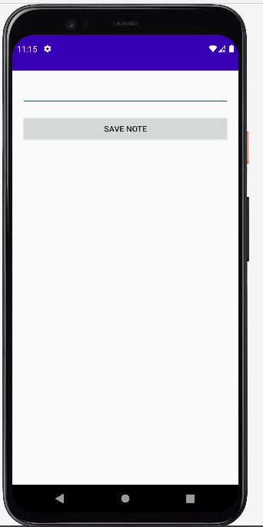

**Lab 2**

Java Code: BMICalculatorActivity.java

|  |
| --- |
| public class BMICalculatorActivity extends AppCompatActivity {  EditText etAge,etHeight,etWeight;  Button btnCalculate;  TextView tvBmiResult;  RadioGroup radioGroupGender;   @Override  protected void onCreate(Bundle savedInstanceState) {  super.onCreate(savedInstanceState);  setContentView(R.layout.*activity_bmicalculator*);   etAge=findViewById(R.id.*et_age*);  etHeight=findViewById(R.id.*et_height*);  etWeight=findViewById(R.id.*et_weight*);  btnCalculate=findViewById(R.id.*btn_calculate*);  tvBmiResult=findViewById(R.id.*tv_bmi_result*);  radioGroupGender=findViewById(R.id.*radio_group_gender*);  tvBmiResult.setText("");   btnCalculate.setOnClickListener(new View.OnClickListener() {  @Override  public void onClick(View view) {  String ageText = etAge.getText().toString().trim();  String heightText = etHeight.getText().toString().trim();  String weightText = etWeight.getText().toString().trim();   int selectedGenderId = radioGroupGender.getCheckedRadioButtonId();  String gender;  if (selectedGenderId == R.id.*radio_male*) {  gender = "Male";  } else if (selectedGenderId == R.id.*radio_female*) {  gender = "Female";  } else {  Toast.*makeText*(BMICalculatorActivity.this, "Please select a gender", Toast.*LENGTH_SHORT*).show();  return;  }  if (ageText.isEmpty()) {  etAge.setError("Please enter your age");  return;  }  if (heightText.isEmpty()) {  etHeight.setError("Please enter your height");  return;  }  if (weightText.isEmpty()) {  etWeight.setError("Please enter your weight");  return;  }  double age = Double.*parseDouble*(ageText);  double height = Double.*parseDouble*(heightText);  double heightInM = height/100;  double weight = Double.*parseDouble*(weightText);   double bmi;  bmi = weight/(heightInM*heightInM);  tvBmiResult.setText("Your BMI is: " + String.*format*("%.2f", bmi));  }  });  } } |

XML/Design Code: *activity_bmicalculator.xml*

|  |
| --- |
| *<?*xml version="1.0" encoding="utf-8"*?>* <LinearLayout  android:padding="16dp"  android:orientation="vertical"  xmlns:android="http://schemas.android.com/apk/res/android"  xmlns:app="http://schemas.android.com/apk/res-auto"  xmlns:tools="http://schemas.android.com/tools"  android:layout_width="match_parent"  android:layout_height="match_parent"  tools:context=".lab2.BMICalculatorActivity">   <RadioGroup  android:id="@+id/radio_group_gender"  android:orientation="horizontal"  android:layout_width="match_parent"  android:layout_height="wrap_content">  <RadioButton  android:text="Male"  android:id="@+id/radio_male"  android:layout_width="wrap_content"  android:layout_height="wrap_content">  </RadioButton>  <RadioButton  android:text="Female"  android:id="@+id/radio_female"  android:layout_width="wrap_content"  android:layout_height="wrap_content">  </RadioButton>  </RadioGroup>   <EditText  android:id="@+id/et_age"  android:layout_marginTop="16dp"  android:inputType="number"  android:hint="Enter your age in years"  android:layout_width="match_parent"  android:layout_height="wrap_content">  </EditText>   <EditText  android:id="@+id/et_height"  android:layout_marginTop="16dp"  android:inputType="number"  android:hint="Enter height in cm"  android:layout_width="match_parent"  android:layout_height="wrap_content">  </EditText>  <EditText  android:id="@+id/et_weight"  android:layout_marginTop="16dp"  android:inputType="number"  android:hint="Enter weight in kg"  android:layout_width="match_parent"  android:layout_height="wrap_content">  </EditText>   <Button  android:id="@+id/btn_calculate"  android:text="Calculate"  android:layout_marginTop="32dp"  android:layout_width="match_parent"  android:layout_height="wrap_content">  </Button>   <TextView  android:id="@+id/tv_bmi_result"  android:textStyle="bold"  android:textSize="20sp"  android:textColor="@color/black"  android:text="Your BMI is 302"  android:layout_marginTop="32dp"  android:layout_width="match_parent"  android:layout_height="wrap_content">  </TextView> </LinearLayout> |

Output:

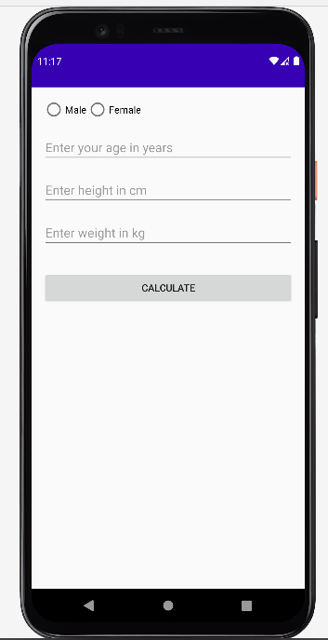

**Lab 3**

Java Code: IntentsActivity.java

|  |
| --- |
| public class IntentsActivity extends AppCompatActivity {  Button btnNextActivity;  @Override  protected void onCreate(Bundle savedInstanceState) {  super.onCreate(savedInstanceState);  setContentView(R.layout.*activity_intents*);  btnNextActivity= findViewById(R.id.*btn_next_activity*);  btnNextActivity.setOnClickListener(new View.OnClickListener() {  @Override  public void onClick(View view) {  startActivity(new Intent(IntentsActivity.this, IntentsActivity2.class));  }  });  } } |

XML/Design Code: *activity_intents.xml*

|  |
| --- |
| *<?*xml version="1.0" encoding="utf-8"*?>* <RelativeLayout  android:padding="16dp"  xmlns:android="http://schemas.android.com/apk/res/android"  xmlns:app="http://schemas.android.com/apk/res-auto"  xmlns:tools="http://schemas.android.com/tools"  android:layout_width="match_parent"  android:layout_height="match_parent"  tools:context=".lab3.IntentsActivity">   <TextView  android:id="@+id/tv_intent1"  android:textSize="20sp"  android:textStyle="bold"  android:layout_centerInParent="true"  android:text="This is first activity/screen"  android:layout_width="wrap_content"  android:layout_height="wrap_content"/>  <Button  android:layout_centerHorizontal="true"  android:layout_marginTop="16dp"  android:layout_below="@id/tv_intent1"  android:text="Next Activity"  android:id="@+id/btn_next_activity"  android:layout_width="wrap_content"  android:layout_height="wrap_content">  </Button> </RelativeLayout> |

Output:

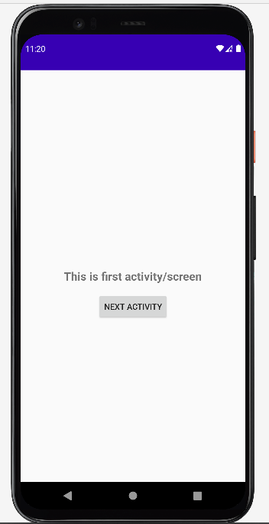

**Lab 4**

Java Code: CrudSqliteActivity.java

|  |
| --- |
| public class CrudSqliteActivity extends AppCompatActivity implements NoteDeleteClickListener, NoteClickListener {  private static final String *TAG* = "CrudSqliteActivity";  DatabaseOperations dbOperations;  EditText etAddNote;  Button btnAddNote;  RecyclerView rcvNotes;  NotesAdapter notesAdapter;  List<NoteModel> notes = new ArrayList<>();   @Override  protected void onCreate(Bundle savedInstanceState) {  super.onCreate(savedInstanceState);  setContentView(R.layout.*activity_crud_sqlite*);  dbOperations = new DatabaseOperations(this);  etAddNote = findViewById(R.id.*et_add_note*);  btnAddNote = findViewById(R.id.*btn_add_note*);  rcvNotes = findViewById(R.id.*rcv_notes*);  btnAddNote.setOnClickListener(new View.OnClickListener() {  @Override  public void onClick(View view) {  String text = etAddNote.getText().toString().trim();  if (text.isEmpty()) {  etAddNote.setError("Please write something");  return;  }  dbOperations.insertData(text);  etAddNote.getText().clear();  setNotesRecycler();  }  });  getNotesData();  setNotesRecycler();  }  private void getNotesData() {  List<NoteModel> dataList = dbOperations.getAllData();  notes.clear();   notes.addAll(dataList);  for (NoteModel i : notes) {  System.*out*.println(i.getNote());  }  }  private void setNotesRecycler() {  getNotesData();  rcvNotes.setLayoutManager(new LinearLayoutManager(this));  if (notesAdapter == null) {  notesAdapter = new NotesAdapter(this, notes, this::onNoteDeleteClicked, this::onNoteClicked);  rcvNotes.setAdapter(notesAdapter);  } else {  notesAdapter.notifyDataSetChanged();  }  }   @Override  public void onNoteDeleteClicked(NoteModel noteModel) {  dbOperations.deleteData(noteModel.getNoteId());  setNotesRecycler();  Log.*d*(*TAG*, "onNoteDeleteClicked: " + noteModel.getNoteId());  Toast.*makeText*(this, "Delete Clicked", Toast.*LENGTH_SHORT*).show();  }  @Override  public void onNoteClicked(NoteModel noteModel) {  Log.*d*(*TAG*, "onNoteClicked: ");  Toast.*makeText*(this, "Clicked", Toast.*LENGTH_SHORT*).show();  showDialog(noteModel);  }  private void showDialog(NoteModel noteModel) {  AlertDialog.Builder builder = new AlertDialog.Builder(this);  View dialogView = getLayoutInflater().inflate(R.layout.*dialog_edit_note*, null);  builder.setView(dialogView);  final EditText editText = dialogView.findViewById(R.id.*etEditNote*);  editText.setText(noteModel.getNote());  builder.setPositiveButton("Yes", (dialogInterface, i) -> {  String enteredText = editText.getText().toString();  dbOperations.updateData(enteredText, noteModel.getNoteId());  setNotesRecycler();  editText.getText().clear();  dialogInterface.dismiss(); *// Dismiss the dialog* });  builder.setNegativeButton("No", (dialogInterface, i) -> dialogInterface.dismiss());  AlertDialog dialog = builder.create();  dialog.show();  } } |

DatabaseHelper.java

|  |
| --- |
| public class DatabaseHelper extends SQLiteOpenHelper {   static final String *TABLE_NAME* = "my_table";  static final String *COLUMN_ID* = "id";  static final String *COLUMN_NAME* = "note";  private static final int *DATABASE_VERSION* = 1;  private static final String *DATABASE_NAME* = "my_database.db";   public DatabaseHelper(Context context) {  super(context, *DATABASE_NAME*, null, *DATABASE_VERSION*);  }  @Override  public void onCreate(SQLiteDatabase db) {  String createTableQuery = "CREATE TABLE " + *TABLE_NAME* + "(" +  *COLUMN_ID* + " INTEGER PRIMARY KEY AUTOINCREMENT," +  *COLUMN_NAME* + " TEXT)";  db.execSQL(createTableQuery);  }  @Override  public void onUpgrade(SQLiteDatabase db, int oldVersion, int newVersion) {  String dropTableQuery = "DROP TABLE IF EXISTS " + *TABLE_NAME*;  db.execSQL(dropTableQuery);  onCreate(db);  } } |

DatabaseOperations.java

|  |
| --- |
| public class DatabaseOperations {  private static final String *TAG* = DatabaseOperations.class.getSimpleName();  private DatabaseHelper dbHelper;  public DatabaseOperations(Context context) {  dbHelper = new DatabaseHelper(context);  }  public void insertData(String name) {  SQLiteDatabase db = dbHelper.getWritableDatabase();  ContentValues values = new ContentValues();  values.put(DatabaseHelper.*COLUMN_NAME*, name);  long newRowId = db.insert(DatabaseHelper.*TABLE_NAME*, null, values);  Log.*d*(*TAG*, "Inserted row id: " + newRowId + "Data:" + name);  *//db.close();* }   public List<NoteModel> getAllData() {  List<NoteModel> dataList = new ArrayList<>();  SQLiteDatabase db = dbHelper.getReadableDatabase();  Cursor cursor = db.query(DatabaseHelper.*TABLE_NAME*, null, null, null, null, null, null);  if (cursor != null && cursor.moveToFirst()) {  do {  int id = cursor.getInt(cursor.getColumnIndex(DatabaseHelper.*COLUMN_ID*));  String name = cursor.getString(cursor.getColumnIndex(DatabaseHelper.*COLUMN_NAME*));  Log.*d*(*TAG*, "Cursor Data - ID = " + id + ", Name = " + name);  NoteModel dataModel = new NoteModel(id, name);  dataList.add(dataModel);  Log.*d*(*TAG*, "getAllData: Data - ID = " + dataModel.getNoteId() + ", Name = " + dataModel.getNote());  } while (cursor.moveToNext());  cursor.close();  }  *//db.close();* return dataList;  }  public void updateData(String newName, int id) {  SQLiteDatabase db = dbHelper.getWritableDatabase();  ContentValues values = new ContentValues();  values.put(DatabaseHelper.*COLUMN_NAME*, newName);  int rowsAffected = db.update(DatabaseHelper.*TABLE_NAME*, values,  DatabaseHelper.*COLUMN_ID* + "=?", new String[]{String.*valueOf*(id)});  Log.*d*(*TAG*, "Rows affected: " + rowsAffected);  *//db.close();* }  public void deleteData(int id) {  SQLiteDatabase db = dbHelper.getWritableDatabase();  int rowsAffected = db.delete(DatabaseHelper.*TABLE_NAME*,  DatabaseHelper.*COLUMN_ID* + "=?", new String[]{String.*valueOf*(id)});  Log.*d*(*TAG*, "Rows affected: " + rowsAffected);  *//db.close();* } }  public class NoteModel {  private String note;  private int noteId;  public NoteModel() {  }  public NoteModel(int noteId, String note) {  this.noteId = noteId;  this.note = note;  }  public String getNote() {  return note;  }  public void setNote(String note) {  this.note = note;  }  public int getNoteId() {  return noteId;  }  public void setNoteId(int noteId) {  this.noteId = noteId;  } } |

NotesAdapter.java

|  |
| --- |
| interface NoteDeleteClickListener {  void onNoteDeleteClicked(NoteModel noteModel); } interface NoteClickListener {  void onNoteClicked(NoteModel noteModel); } public class NotesAdapter extends RecyclerView.Adapter<NotesAdapter.NotesViewHolder> {  private static final String *TAG* = "NotesAdapter";  private Context context;  private List<NoteModel> noteModelList;  private NoteDeleteClickListener noteDeleteClickListener;  private NoteClickListener noteClickListener;   public NotesAdapter(Context context, List<NoteModel> noteModelList, NoteDeleteClickListener noteDeleteClickListener, NoteClickListener noteClickListener) {  this.context = context;  this.noteModelList = noteModelList;  this.noteDeleteClickListener = noteDeleteClickListener;  this.noteClickListener = noteClickListener;  }   @NonNull  @Override  public NotesViewHolder onCreateViewHolder(@NonNull ViewGroup parent, int viewType) {  Log.*d*(*TAG*, "onCreateViewHolder: notesSize:" + noteModelList.size());  View view = LayoutInflater.*from*(parent.getContext()).inflate(R.layout.*single_note*, parent, false);  return new NotesViewHolder(view);  }   @Override  public void onBindViewHolder(@NonNull NotesViewHolder holder, int position) {  NoteModel noteModel = noteModelList.get(position);  holder.tvNotes.setText(noteModel.getNote());  Log.*d*(*TAG*, "onBindViewHolder: " + noteModel.getNote());  holder.cardNote.setOnClickListener(new View.OnClickListener() {  @Override  public void onClick(View view) {  noteClickListener.onNoteClicked(noteModel);  }  });  holder.btnDelete.setOnClickListener(view -> {  if (position != RecyclerView.*NO_POSITION*) {  noteDeleteClickListener.onNoteDeleteClicked(noteModel);  }  });  }   @Override  public int getItemCount() {  return noteModelList.size();  }   class NotesViewHolder extends RecyclerView.ViewHolder {  TextView tvNotes;  ImageButton btnDelete;  CardView cardNote;   public NotesViewHolder(@NonNull View itemView) {  super(itemView);  int position = getAdapterPosition();  Log.*d*(*TAG*, "NotesViewHolder: position:" + position);  tvNotes = itemView.findViewById(R.id.*tv_note*);  cardNote = itemView.findViewById(R.id.*card_note*);  btnDelete = itemView.findViewById(R.id.*btn_delete*);    }  } } |

*activity_crud_sqlite*.xml

|  |
| --- |
| *<?*xml version="1.0" encoding="utf-8"*?>* <LinearLayout xmlns:android="http://schemas.android.com/apk/res/android"  xmlns:tools="http://schemas.android.com/tools"  android:layout_width="match_parent"  android:layout_height="match_parent"  android:orientation="vertical"  android:padding="16dp"  tools:context=".lab4.CrudSqliteActivity">   <EditText  android:id="@+id/et_add_note"  android:layout_width="match_parent"  android:layout_height="wrap_content"></EditText>   <Button  android:id="@+id/btn_add_note"  android:layout_width="match_parent"  android:layout_height="wrap_content"  android:layout_marginTop="16dp"  android:text="Save Note"></Button>   <androidx.recyclerview.widget.RecyclerView  android:id="@+id/rcv_notes"  android:layout_width="match_parent"  android:layout_height="wrap_content"></androidx.recyclerview.widget.RecyclerView>  </LinearLayout> |

single_note.xml

|  |
| --- |
| *<?*xml version="1.0" encoding="utf-8"*?>* <androidx.cardview.widget.CardView xmlns:android="http://schemas.android.com/apk/res/android"  xmlns:app="http://schemas.android.com/apk/res-auto"  android:id="@+id/card_note"  android:layout_width="match_parent"  android:layout_height="wrap_content"  android:layout_marginTop="8dp"  app:contentPadding="8dp">   <LinearLayout  android:layout_width="match_parent"  android:layout_height="wrap_content"  android:gravity="center">   <TextView  android:id="@+id/tv_note"  android:layout_width="0dp"  android:layout_height="wrap_content"  android:layout_marginEnd="16dp"  android:layout_weight="1"  android:text="This will hold text of note"  android:textColor="@color/black"></TextView>   <ImageButton  android:id="@+id/btn_delete"  android:layout_width="50dp"  android:layout_height="50dp"  android:src="@drawable/baseline_delete_24"  app:tint="#FF0000"></ImageButton>  </LinearLayout>  </androidx.cardview.widget.CardView> |

Output:

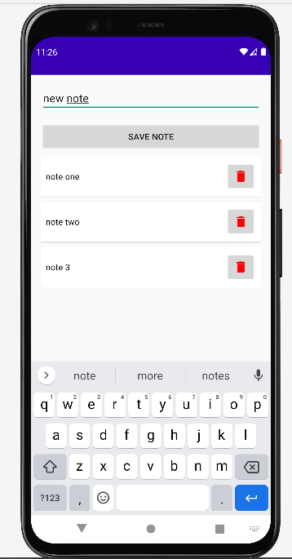

**Lab 5**

Java Code: VolleyPhpActivity.java

|  |
| --- |
| public class VolleyPhpActivity extends AppCompatActivity {  private static final String *TAG* = "VolleyPhpActivity";  *// private static final String JSON_PLACEHOLDER_URL = "http://localhost/get_posts.php";* private static final String *JSON_PLACEHOLDER_URL* = "http://10.0.2.2/get_posts.php";  ProgressDialog progressDialog;  TextView tvResponseText;   @Override  protected void onCreate(Bundle savedInstanceState) {  super.onCreate(savedInstanceState);  setContentView(R.layout.*activity_volley_php*);  tvResponseText = findViewById(R.id.*tv_response_text*);  progressDialog = new ProgressDialog(this);  getData();  }   private void getData() {  progressDialog.show();  RequestQueue requestQueue = Volley.*newRequestQueue*(this);  JsonArrayRequest jsonArrayRequest = new JsonArrayRequest(  Request.Method.*GET*,  *JSON_PLACEHOLDER_URL*,  null,  new Response.Listener<JSONArray>() {  @Override  public void onResponse(JSONArray response) {  handleResponse(response);  Toast.*makeText*(VolleyPhpActivity.this, "Success fetching data", Toast.*LENGTH_SHORT*).show();  }  },  new Response.ErrorListener() {  @Override  public void onErrorResponse(VolleyError error) {  Log.*d*(*TAG*, "onErrorResponse: " + error.getMessage());  Log.*d*(*TAG*, "onErrorResponse: " + error.toString());  Log.*d*(*TAG*, "onErrorResponse: " + error.getLocalizedMessage());  Log.*d*(*TAG*, "onErrorResponse: " + error.getCause());  if (error.networkResponse != null) {  int statusCode = error.networkResponse.statusCode;  Log.*e*(*TAG*, "Error response code: " + statusCode);  }  Toast.*makeText*(VolleyPhpActivity.this, "Error retrieving data", Toast.*LENGTH_SHORT*).show();  }  });  requestQueue.add(jsonArrayRequest);  }   private void handleResponse(JSONArray jsonArray) {  StringBuilder result = new StringBuilder();  try {  for (int i = 0; i < jsonArray.length(); i++) {  JSONObject jsonObject = jsonArray.getJSONObject(i);  int postId = jsonObject.getInt("id");  String title = jsonObject.getString("title");  String body = jsonObject.getString("body");  result.append(String.*valueOf*(i + 1)).append("\t").append(title).append("\n\n\n");  }  } catch (JSONException e) {  Log.*e*(*TAG*, "Error parsing JSON: " + e.getMessage());  }  tvResponseText.setText(result.toString());  progressDialog.dismiss();  } } |

activity_volley.xml

|  |
| --- |
| *<?*xml version="1.0" encoding="utf-8"*?>* <LinearLayout  android:padding="16dp"  xmlns:android="http://schemas.android.com/apk/res/android"  xmlns:app="http://schemas.android.com/apk/res-auto"  xmlns:tools="http://schemas.android.com/tools"  android:layout_width="match_parent"  android:layout_height="match_parent"  tools:context=".lab5.VolleyPhpActivity">    <TextView  android:id="@+id/tv_response_text"  android:layout_width="match_parent"  android:layout_height="match_parent">  </TextView> </LinearLayout> |

Output:

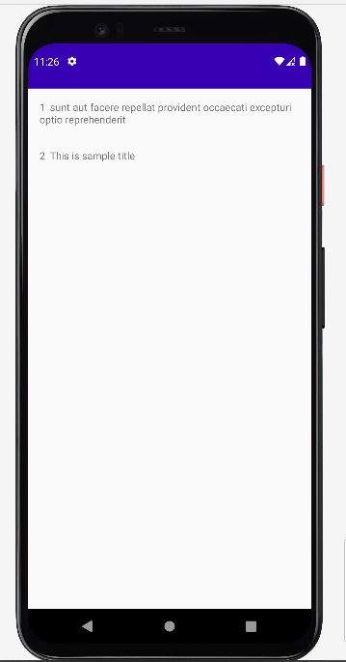

**Lab 6**

Java Code: VolleyApiActivity.java

|  |
| --- |
| public class VolleyApiActivity extends AppCompatActivity {  private static final String *TAG*="VolleyApiActivity";  private static final String *JSON_PLACEHOLDER_URL*="https://jsonplaceholder.typicode.com/posts";  ProgressDialog progressDialog;  TextView tvResponseText;   @Override  protected void onCreate(Bundle savedInstanceState) {  super.onCreate(savedInstanceState);  setContentView(R.layout.*activity_volley_api*);  tvResponseText= findViewById(R.id.*tv_response_text*);  progressDialog= new ProgressDialog(this);  getData();  }   private void getData() {  progressDialog.show();  RequestQueue requestQueue = Volley.*newRequestQueue*(this);  JsonArrayRequest jsonArrayRequest = new JsonArrayRequest(  Request.Method.*GET*,  *JSON_PLACEHOLDER_URL*,  null,  new Response.Listener<JSONArray>() {  @Override  public void onResponse(JSONArray response) {  handleResponse(response);  Toast.*makeText*(VolleyApiActivity.this, "Success fetching data", Toast.*LENGTH_SHORT*).show();  }  },  new Response.ErrorListener() {  @Override  public void onErrorResponse(VolleyError error) {  Toast.*makeText*(VolleyApiActivity.this, "Error retrieving data", Toast.*LENGTH_SHORT*).show();  Log.*e*(*TAG*, "Error retrieving data: " + error.getMessage());  }  });  requestQueue.add(jsonArrayRequest);  }  private void handleResponse(JSONArray jsonArray) {  StringBuilder result= new StringBuilder();  try {  for (int i = 0; i < jsonArray.length(); i++) {  JSONObject jsonObject = jsonArray.getJSONObject(i);  int postId = jsonObject.getInt("id");  String title = jsonObject.getString("title");  String body = jsonObject.getString("body");  result.append(String.*valueOf*(i + 1)).append("\t").append(title).append("\n\n\n");  }  } catch (JSONException e) {  Log.*e*(*TAG*, "Error parsing JSON: " + e.getMessage());  }  tvResponseText.setText(result.toString());  progressDialog.dismiss();  } } |

*activity_volley_api*.xml

|  |
| --- |
| *<?*xml version="1.0" encoding="utf-8"*?>* <ScrollView  android:padding="16dp"  xmlns:android="http://schemas.android.com/apk/res/android"  xmlns:app="http://schemas.android.com/apk/res-auto"  xmlns:tools="http://schemas.android.com/tools"  android:layout_width="match_parent"  android:layout_height="match_parent"  tools:context=".lab6.VolleyApiActivity">   <TextView  android:id="@+id/tv_response_text"  android:layout_width="match_parent"  android:layout_height="match_parent">  </TextView>  </ScrollView> |

Output:

